**Academic Year: 2023-24                                           Name of Student:**

**Semester: III   Student ID:**

**Class / Branch/ Div: SE- IT A/ B/ C   Roll No.**

**Subject: Data Structure Lab     Date of Submission:**

**Name of Instructor:**

**Experiment No.7**

**Aim:**  Implementation of Binary Search.

**Prerequisites**: - arrays in c

**Objectives: -** At the end of this experiment, you will be able to:

* Understand divide and conquer principal
* Understand binary search on the array

**Code:**

#include <stdio.h>

int main()

{

  int c, first, last, middle, n, search, array[10];

  printf("Enter number of elements\n");

  scanf("%d", &n);

  printf("Enter %d integers\n", n);

  for (c = 0; c < n; c++)

    scanf("%d", &array[c]);

  printf("Enter value to find\n");

  scanf("%d", &search);

  first = 0;

  last = n - 1;

  middle = (first+last)/2;

  while (first <= last) {

    if (array[middle] < search)

      first = middle + 1;

    else if (array[middle] == search) {

      printf("%d found at location %d.\n", search, middle+1);

      break;

    }

    else

      last = middle - 1;

    middle = (first + last)/2;

  }

  if (first > last)

    printf("Not found! %d isn't present in the list.\n", search);

  return 0;

}

**Output:**

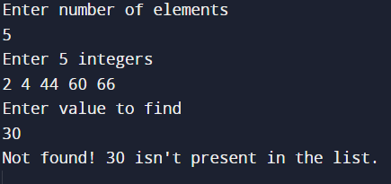

**Conclusion: -**

Thus in this experiment we implemented binary search where the requirement is to give the sorted integer array as an input.